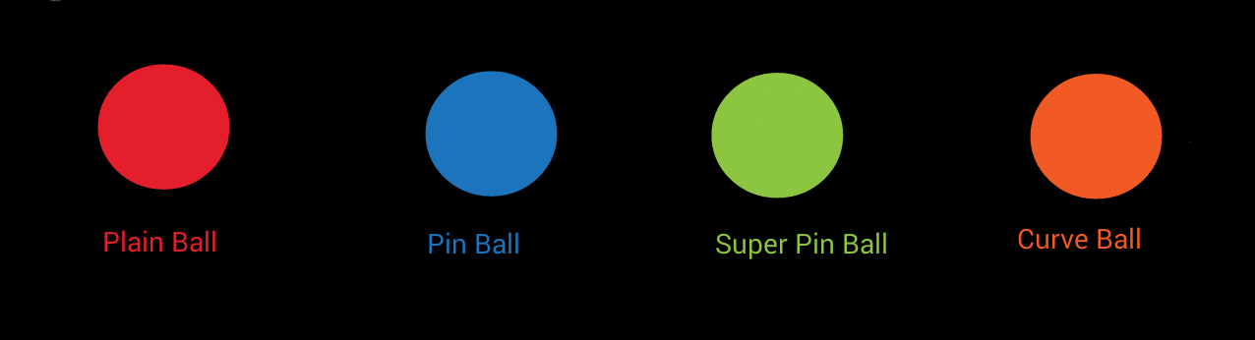

Plain Ball – Will be the normal ball (Super Class) used during the game, will bounce off walls and the racquets at a constant speed

Pin Ball – Inherits from Plain Ball. When it makes contact with a racquet it will act as a pinball in a launcher with the player having to pull back and shoot it out in any direction, the speed will depend on how far back the ball is pulled

Super Pin Ball – Inherits from Plain Ball. Can “break” through certain racquets of the opponents:

Can Break Through Cannot Break Through Will Ricochet and Break

- Plain Racquet - Shield - Broad

- XL Racquet - Net

Curve Ball – Will inherit from the Plain Ball. Moves in an elliptical path